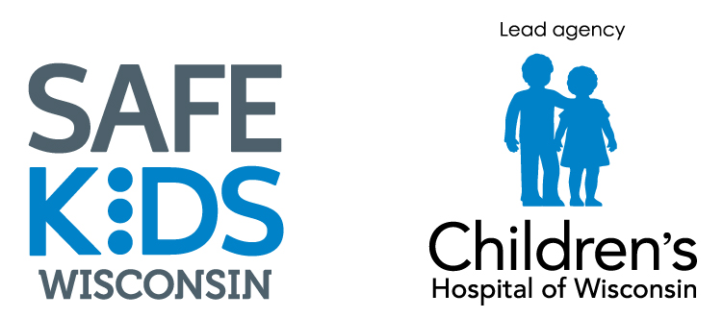
Wisconsin
Child Passenger Safety Program

Wisconsin Child Passenger Safety Advisory Board Meeting
Wednesday, November 7th, 2018
10:30-2:00 p.m.
Fire Station 13- Madison, WI

Meeting Goals:
- Finalize and “vote” on adopting operating guidelines.
- Seek ideas for new projects
- Detailing out members and working on a plan to fill vacancies and see what agencies aren’t represented on the board.
- Review of Governor’s Conference, share feedback and discuss 2019

Agenda
- Introduction
- Updates
- Operating Guidelines
- Lunch
- Advisory Board Members
- Governor’s Conference
- New Projects
- Next Steps

