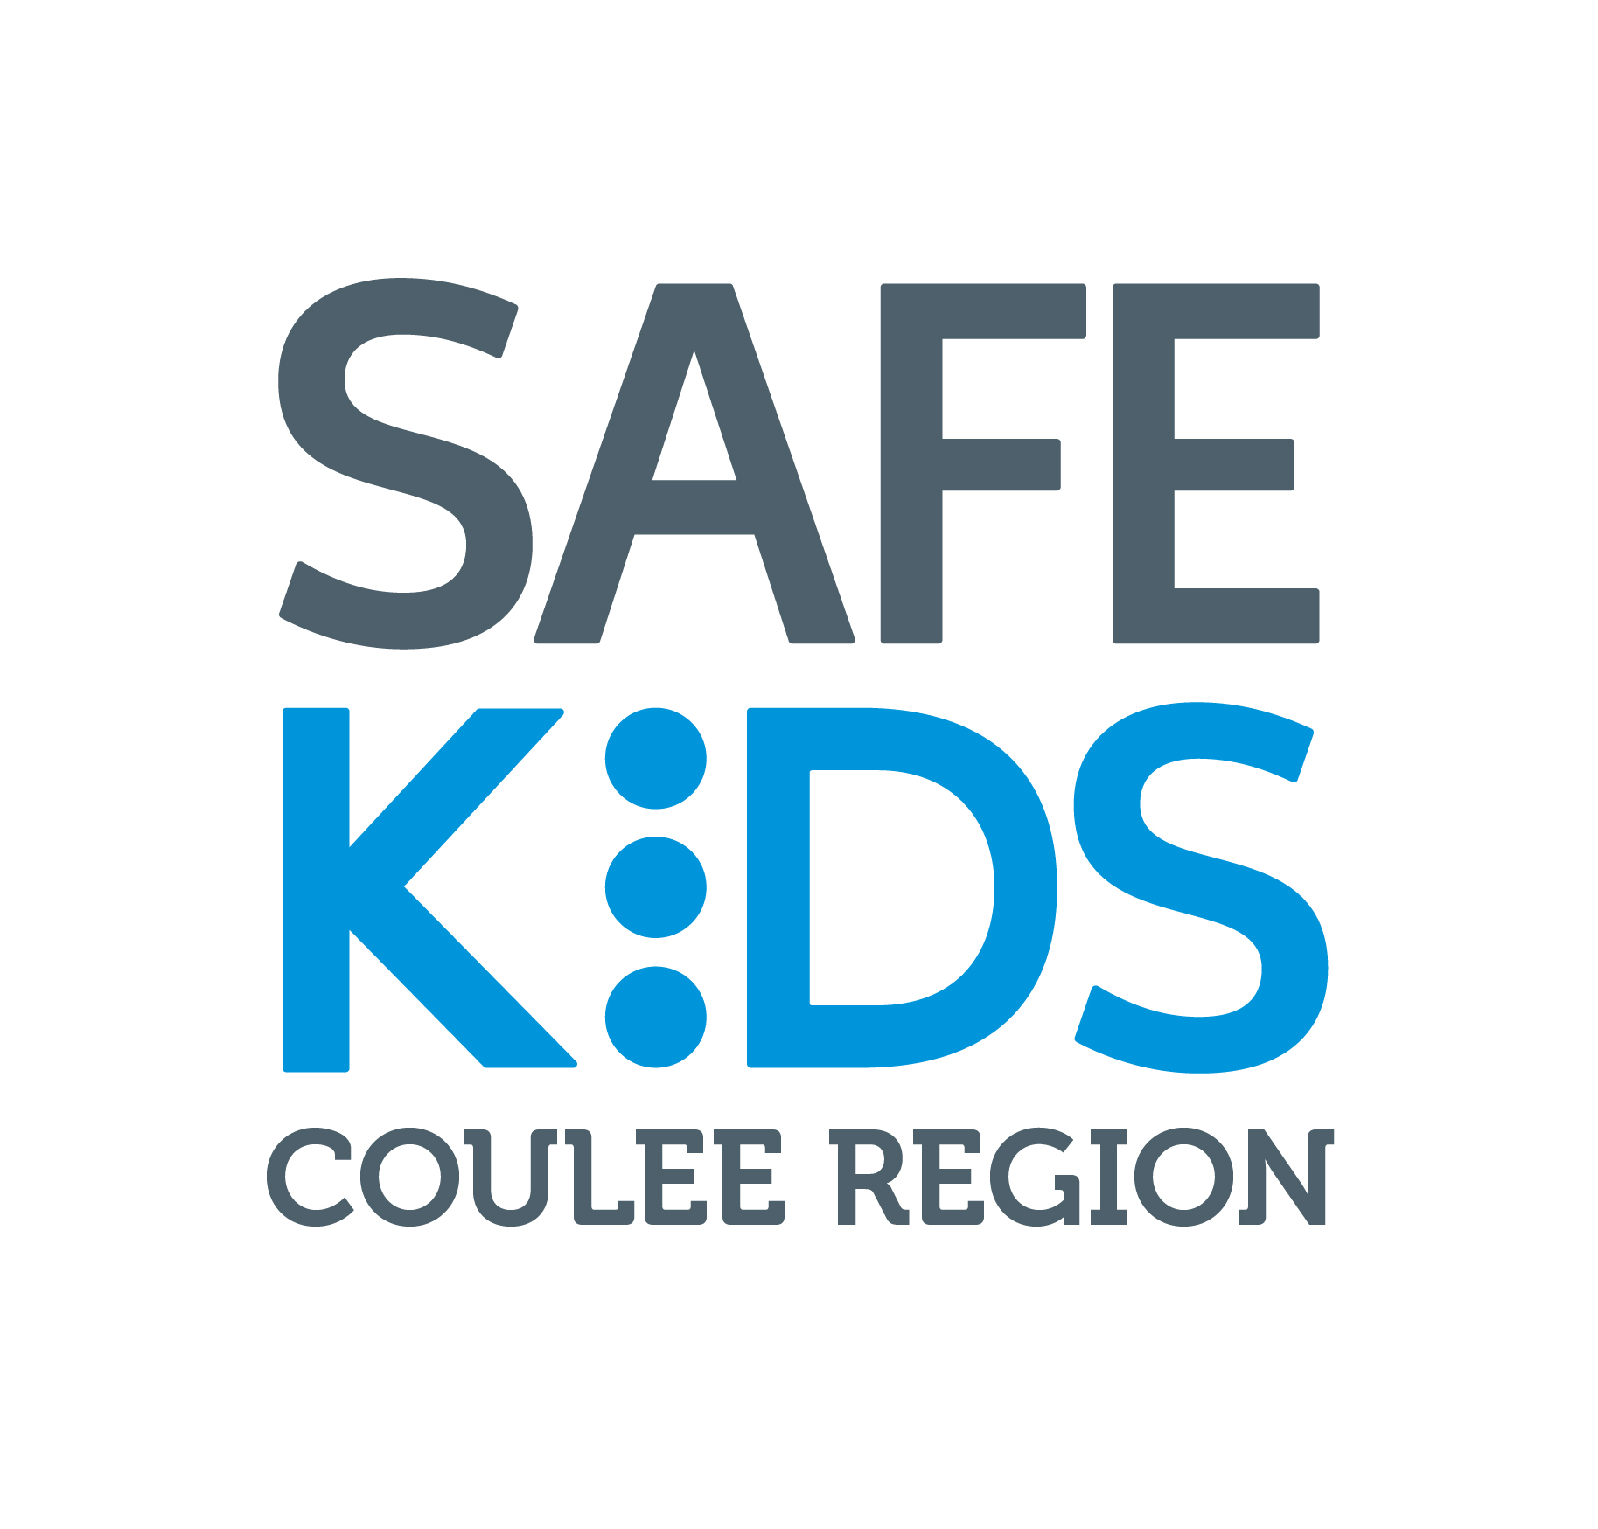

Membership Agreement Form

Thank you for your interest in the Safe Kids Coulee Region Coalition. As a member we ask that you, on behalf of your organization, become a community partner in the prevention of unintentional childhood injury. In doing so, you join the thousands of professionals internationally working to make the world a safer place to raise our children. Complete the form below and have your supervisor (if applicable) sign this document to solidify the partnership between you, your organization and Safe Kids Coulee Region Coalition. By committing to working together we can make a difference.

Name:

Title:

Organization:

Address:

E-mail Address:

Phone: | Fax:

I, on behalf of my agency, am interested in serving the Coalition in the following capacity (choose at least one):

Being a volunteer to help conduct Coalition activities/promote Safe Kids

Supporting Coalition activities with donations of funding or in-kind services

Incorporating Coalition information or activities into my own organizations’ publications or programs
Attend Coalition meetings

Please check events and programs that you are interested in becoming involved in.
____ Water Safety
____ Fire Safety
____ Child Passenger Safety/Motor Vehicle Safety
____ Falls Prevention
____ Pedestrian Safety/International Walk to School Day
____ Slide Into Safety
____ Sports Safety
____ Safe Sleep
____ Poisoning
____ Other:_____________________________

Member Signature Date

